Color Catch

A PROJECT REPORT

Submitted by

Anish Acharya(1418BECE30012)

In fulfillment for the award of the degree
of
BACHELOR OF ENGINEERING
in
CE(1ST Shift)

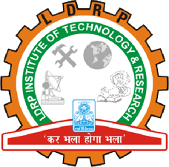

LDRP Institute of Technology and Research, Gandhinagar
Kadi Sarva Vishwavidyalaya
July, 2017

LDRP Institute of Technology and Research
Gandhinagar

CE-IT Department
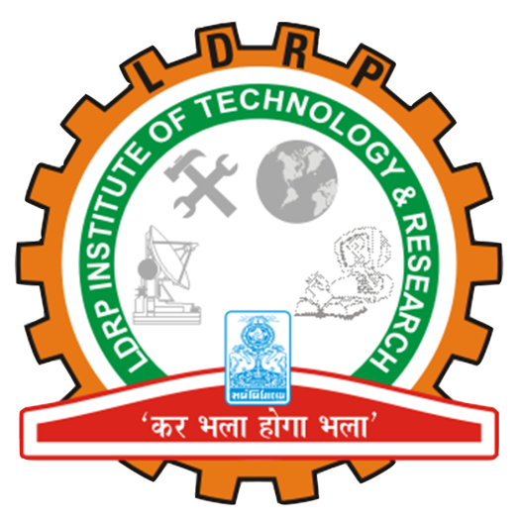

CERTIFICATE
This is to certify that the Project Work entitled “Color Catch” has been carried out by Anish Acharya (1418BECE30012) under my guidance in fulfilment of the degree of Bachelor of Engineering in Computer Engineering (7th Semester) of Kadi Sarva Vishwavidyalaya during the academic year 2017-18.

Krutika Vyas Dr.Hiren B. Patel
Internal Guide Head of the Department
LDRP ITR LDRP ITR

